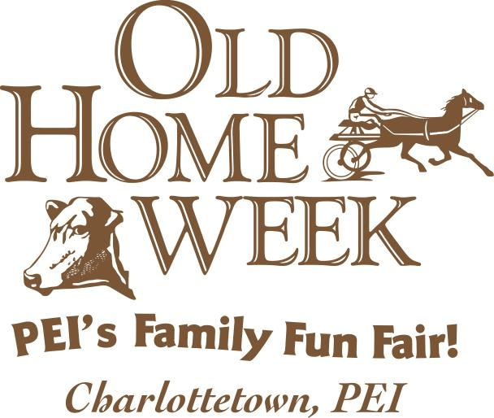
Exhibitor:________________________________________________
Please Print or Type Entries Address:_________________________________________________
Consult Prize List for Class Numbers City: _________________________________ Province:_____
Postal Code: ___________Phone: (_____)___________________
Only One Owner & Breed Per Form Email:________________________________________________
Breed: __________________________________________________
Questions? : Email: info@oldhomeweekpei.com or Call (902)629-6623

Entry Fee Total | _____ x $10 | $ | Please Indicate:  PRIZE MONEY CHEQUE TO BE MADE PAYABLE TO:  ____________________________________________  Stable With _________________________________  Mail Entries to: Old Home Week Box 3070  Charlottetown, PE C1A 7N9  Or scan and send to info@oldhomeweekpei.com  Etransfer info@oldhomeweekpei.com
Exhibitor Passes | _____ x $25 | $
Camping Space (Limited)  Arrival Day:_________ | ____ x $20 per night  Departure Day:_______________ | $
Total Fees Due |  | $
Please Make Cheque Payable to PEI Provincial Exhibition Inc.
Or etransfer to info@oldhomeweekpei.com
Office Use Only | Entries Received | Amount
I hereby make the following entry subject to the rules and conditions in the prize list. The PEI PROVINCIAL
EXHIBITION will not be responsible or liable for any loss, damage or injury.

Signature: _________________________________
Print Full Name: ____________________________
Date:_______________________________

Page ___ of ____
Circle Show to be Entered: CHAROLAIS ANGUS HEREFORD SPECKLEPARK COMM SIMM SHEEP: SUF/HAMP AOB ML
* | Class # | Animal Name |  | DOB (M/D/Y)
* | Reg.# |  |  | Tattoo #
* | Sire |  |  | Dam
* | Owner (exactly as shown on papers) |  |  |  | Bred & Owned Y N
* | Breeder Name (if different) |  | OFFICE USE ONLY  Placing/Money Owed
* | Breeder Address

Circle Show to be Entered: CHAROLAIS ANGUS HEREFORD SPECKLEPARD COMM SHEEP: SUF/HAMP AOB ML
* | Class # | Animal Name |  | DOB (M/D/Y)
* | Reg.# |  |  | Tattoo #
* | Sire |  |  | Dam
* | Owner (exactly as shown on papers) |  |  |  | Bred & Owned Y N
* | Breeder Name (if different) |  | OFFICE USE ONLY  Placing/Money Owed
* | Breeder Address

Circle Show to be Entered: CHAROLAIS ANGUS HEREFORD SPECKLEPARK COMM SHEEP: SUF/HAMP AOB ML
* | Class # | Animal Name |  | DOB (M/D/Y)
* | Reg.# |  |  | Tattoo #
* | Sire |  |  | Dam
* | Owner (exactly as shown on papers) |  |  |  | Bred & Owned Y N
* | Breeder Name (if different) |  | OFFICE USE ONLY  Placing/Money Owed
* | Breeder Address

Page __ of ___

